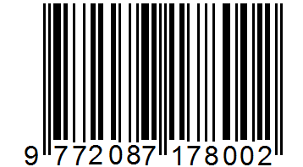

VOL. 4, No. 2, MARET 2020 ISSN 2087-1783 (CETAK)
ISSN 2580-5320 (ONLINE)


